Give THANKS for those who gave so much…
Piedmont Car Show, Swap Meet and Fall Celebration
Benefitting Navy Seal Foundation, local law enforcement & Cobb youth programs
Offered by the Peach State Cadillac & LaSalle Club, Piedmont Church and Cadillac of Lake Lanier

INFORMATION YOU CAN USE

CAR SHOW, Swap Meet and Car Corral: Piedmont Church, 570 Piedmont Road, Marietta, GA 30066. Voting by DOLLAR contributions to the cause – all visitors are invited to VOTE WITH THEIR BUCKS! Awards will be for the vehicles drawing the most contributions. An auction, a 50-50 raffle, door prizes and more. Food trucks, a DJ, and lots of car-related FUN! Be sure to order a full color, themed t-shirt!

SATURDAY, November 16: Day-of-show registration begins at 8:00 AM. Registration until noon, Voting with Dollars ends at 2:00 PM. Awards ceremony and trophy presentations at 2:30 PM. Register your car, truck or motorcycle for $20 up to November 1st ($25 after the 1st). Vendors, Car Corral, Swap Meet Spaces, car care displays start at $25 per space. Rates are higher on the day of the show.

DIRECTIONS TO THE Piedmont Church: From the NORTH or SOUTH on I-75 or I-575, take Barrett Parkway exit, and turn EAST. Go 1.7 miles. Barrett becomes Piedmont Road. Piedmont Church is on the right. From the WEST: Go east on Hwy 120, turn north on Barrett Parkway, and swing eastward until it becomes Piedmont Road. From the EAST: Use I-285 to North I-575 then follow directions from I-575.

FOR ADDITIONAL INFORMATION, OR TO REGISTER ONLINE:
http://www.peachstateclc.org/nov-16-navy-seal-benefit-event.html

QUESTIONS? Call:
- Tom Di Nucci (Peach State Cadillac car show coordinator): (770) 479-9328
- Doug Bailey (Peach State Cadillac president): (404) 786-6077
- Marty Pecora (Cadillac of Lake Lanier Office): (866) 371-4474
- Or, email Tom at ltd9328@comcast.net

GUIDELINES: We ask that you honor the following guidelines so we can all have a great time:
- Please bring a bucket or box to capture voters’ dollars. Make up a label or we will supply one.
- No pop-up tents will be allowed on show field.
- No alcoholic beverages are permitted anywhere on Piedmont Church property.
- No food or drinks are allowed inside church buildings.
- No refunds will be issued for cancellation due to weather, acts of God or unforeseen events.
- Classes will be judged by DOLLAR VOTING. Anyone with a dollar bill (or lots) can vote.
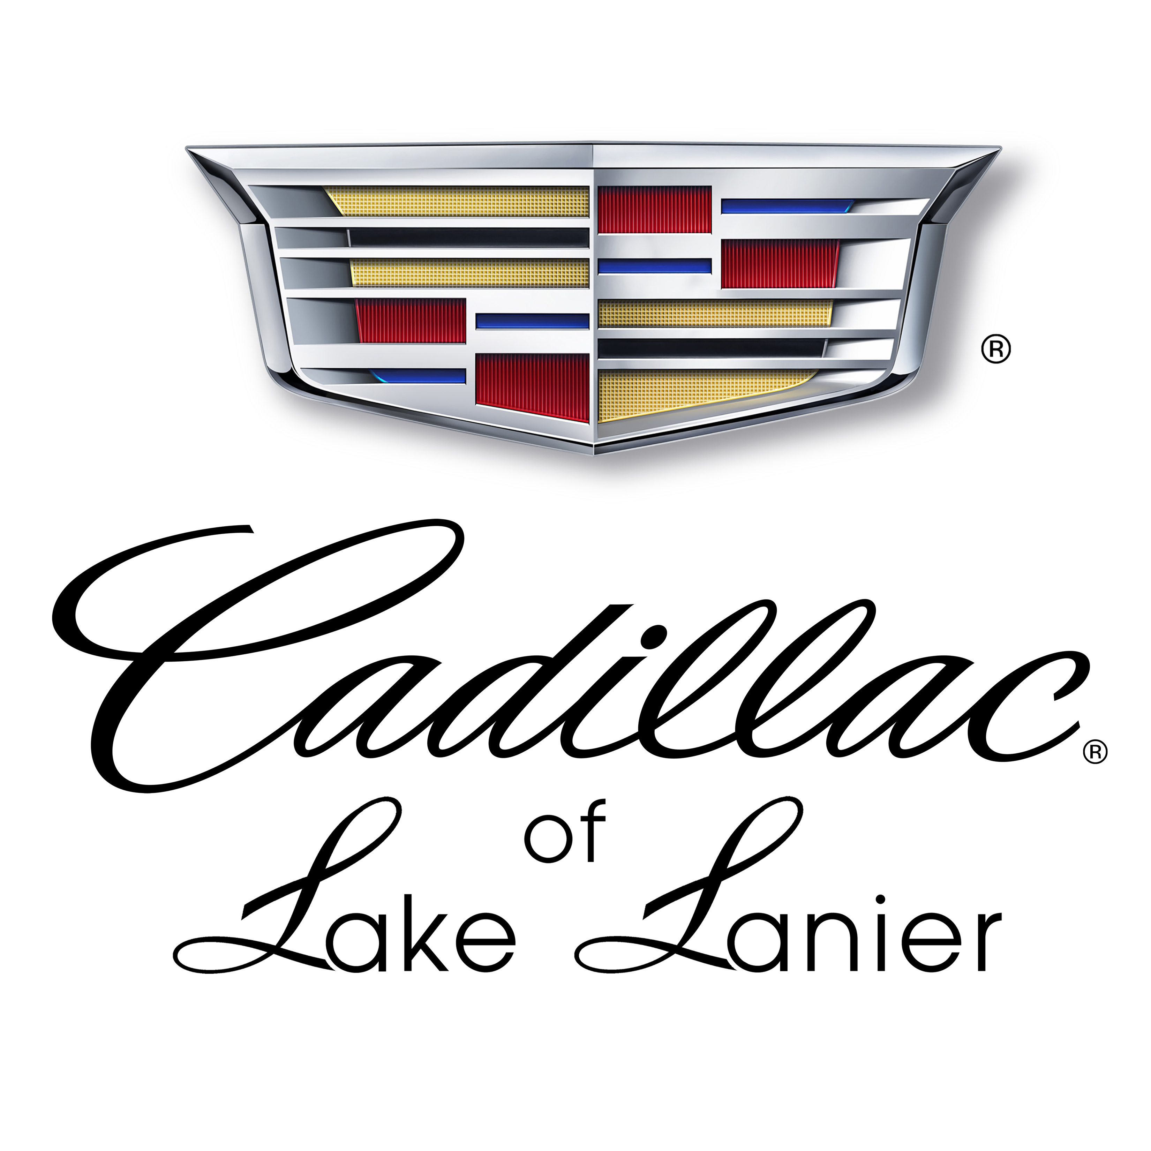
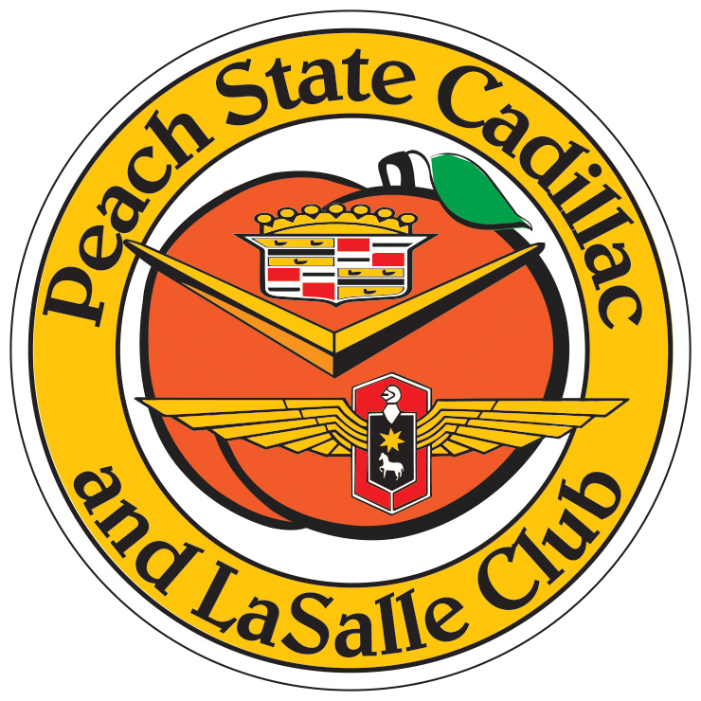
- All cars must have fire extinguishers displayed on the ground under the wheel.
Piedmont Car Show Benefit - Registration Form
Give THANKS for those who gave so much…
Piedmont Car Show, Swap Meet and Fall Celebration
Benefitting Navy Seal Foundation, local law enforcement and Cobb youth programs
Saturday, November 16, 2019
Offered by the Peach State Cadillac & LaSalle Club, Piedmont Church and Cadillac of Lake Lanier

Participant Registration (all fields required):
First and Last Name: .
Street: City: State: Zip:
Phone: email address:
Vehicle Registration (all fields required):
 MODERN CAR  CLASSIC CAR  MOTORCYCLE  TRUCK  OTHER

YEAR: MAKE: MODEL:
BODY STYLE: Club Affiliation:
Please save me space for a car trailer:  YES  NO
Would you like information about joining one of these clubs?
 ROMEOs  Dixie Olds  SEGTOA (Pontiac)  Peach State Cadillac  Po Boys
 Georgia Cool Cruisers  Lanier Corvettes  MOPAR  Dixie Classic Chevy

Postmarked no later than November 1: $20………………………….…………………………………………………$ .
Postmarked after November 1: $25 ………………………………………………………………………………………..$ .
Commemorative T-Shirts (circle): M, L, XL @ $25………………………………..……….# ………………..$ .
XL, XXXL @ $28…..…………………………………….# ………………..$ .
Vendor Spaces (postmarked by November 1): $25………………………………………# …..……………$ .
(postmarked after November 1): $30. ………………………………# ………………..$ .

TOTAL REGISTRATION FEES: ………………………………….$ .

Make checks payable to Peach State CLC. Mail to Michelle Anderson, PO Box 6301, Dalton GA 30722.
Send your PayPal payment to Peach_State_CLC_Members@yahoo.com (underscores between words)

Submitting this form confirms that I agree to indemnify, protect, defend and hold harmless the Cadillac & LaSalle Club, its Peach State regional affiliate, and Piedmont Church from and against any and all claims, costs, liabilities and attorney’s fees arising from damage or injury, actual or claimed, of any kind of nature, to property or persons, resulting from my participation in the Car Show to benefit Navy Seal Foundation. The owner/driver has proof of bodily injury and property damage liability insurance on the entered vehicle. The owner/driver certifies that the described vehicle entered in this event has met the requirements of the motor vehicle authorities, or other governing bodies of the state in which the vehicle is registered, and that the vehicle is legally registered and/or licensed. The CLC, its Peach State regional affiliate, and Piedmont Church will not, and cannot, be held responsible for property damage or personal injury involving any participating vehicle.

Owner/Driver Signature: ____________________________ Date: ____________ (Rev A 09-20-2019)

